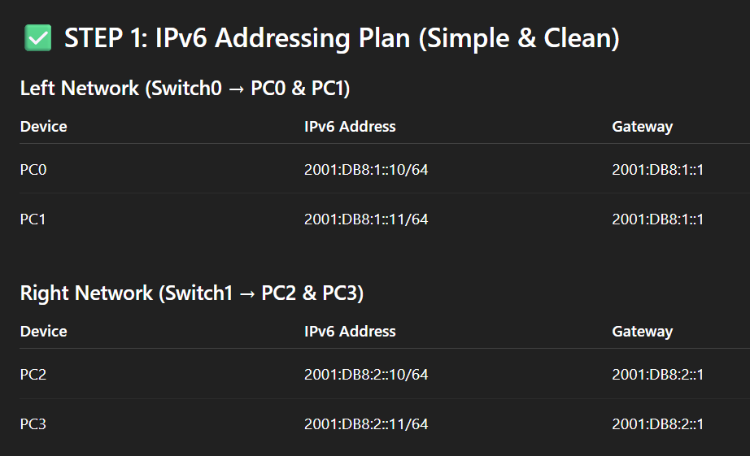

Router>enable
Router#conf t
Enter configuration commands, one per line. End with CNTL/Z.
Router(config)#ipv6 unicast-routing
Router(config)#interface gigabitEthernet0/0
Router(config-if)#ipv6 address 2001:DB8:1::1/64
Router(config-if)#no shutdown
Router(config-if)#exit
Router(config)#interface gigabitEthernet0/1
Router(config-if)#ipv6 address 2001:DB8:2::1/64
Router(config-if)#no shutdown
Router(config-if)#exit
Router(config)#end
Router#
%SYS-5-CONFIG_I: Configured from console by console
Router#write
Building configuration...
[OK]
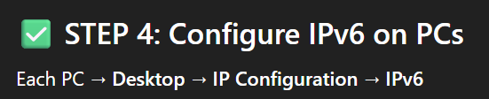
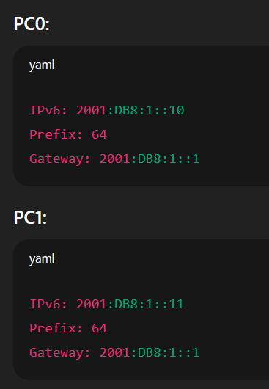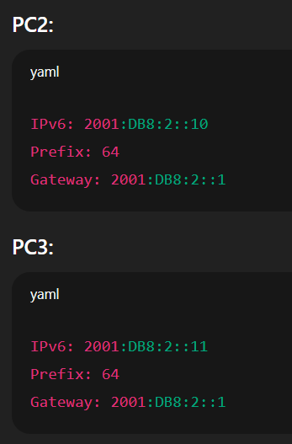
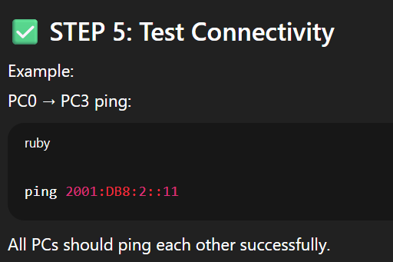
1. Aim
Configure IPv6 addressing on a router and connected hosts, enable IPv6 routing, verify connectivity using ICMPv6, and observe IPv6 routing/neighbor tables.
2. Theory (brief)
IPv6 is the next-generation Internet Protocol addressing scheme using 128-bit addresses. Key IPv6 concepts for this lab:
- Global unicast addresses (e.g., 2001:db8::/32 for documentation) — used like IPv4 public addresses.
- Link-local addresses (fe80::/10) — automatically configured on interfaces for neighbor discovery and local communication.
- ICMPv6 handles neighbor discovery (replaces ARP) and echo (ping6).
- IPv6 routing: routers forward IPv6 packets when ipv6 unicast-routing is enabled.

3. Topology (logical)
[PC0 - LAN1] --- Switch --- Gig0/0 (Router) Gig0/1 --- Switch --- [PC1 - LAN2]
R1
- Router has two interfaces: GigabitEthernet0/0 (LAN1) and GigabitEthernet0/1 (LAN2).
- Example global prefixes used in this lab: 2001:db8:1::/64 and 2001:db8:2::/64.

4. Addressing Scheme (example)
Device | Interface | IPv6 Address (Global) | Prefix
PC0 | NIC | 2001:db8:1::10 | /64
R1 | G0/0 | 2001:db8:1::1 | /64
R1 | G0/1 | 2001:db8:2::1 | /64
PC1 | NIC | 2001:db8:2::10 | /64
All devices should also have link-local addresses (auto-configured).

5. Devices / Tools Required
- Cisco Router (Packet Tracer)
- 2 PCs
- 1 or 2 Switches
- Console/CLI access to router and PC terminal

6. Procedure (step-by-step CLI)
A. Router basic IPv6 configuration
Enter privileged mode and global configuration:
Router> enable
Router# configure terminal
Enable IPv6 routing on the router (needed to forward IPv6 packets):
Router(config)# ipv6 unicast-routing
Configure interface GigabitEthernet0/0 (LAN1):
Router(config)# interface gigabitEthernet0/0
Router(config-if)# ipv6 address 2001:DB8:1::1/64
Router(config-if)# no shutdown
Router(config-if)# exit
Configure interface GigabitEthernet0/1 (LAN2):
Router(config)# interface gigabitEthernet0/1
Router(config-if)# ipv6 address 2001:DB8:2::1/64
Router(config-if)# no shutdown
Router(config-if)# exit
Save configuration:
Router(config)# end
Router# write
(This sequence follows the example from the uploaded file.)
B. Configure IPv6 on PCs
On each PC (or host) set the IPv6 global address and default gateway.
PC0 (LAN1):
- IPv6 address: 2001:db8:1::10/64
- Default gateway: 2001:db8:1::1
PC1 (LAN2):
- IPv6 address: 2001:db8:2::10/64
- Default gateway: 2001:db8:2::1
(Alternatively, enable SLAAC if Router Advertisements are configured — not covered in this simple lab.)
C. (If multiple routers) Add IPv6 static routes or enable a routing protocol
For multi-router labs add routes. Example static route on R1 to reach other networks:
Router(config)# ipv6 route 2001:db8:3::/64 2001:db8:2::2
Or enable an IPv6 routing protocol (e.g., OSPFv3, EIGRP for IPv6) if required by the lab.

7. Verification / Tests
- Show configured IPv6 interfaces
Router# show ipv6 interface brief
- Show IPv6 routing table
Router# show ipv6 route
- Show IPv6 neighbors (ND/ARP equivalent)
Router# show ipv6 neighbors
- From PC0, ping the router and PC1
PC0> ping 2001:db8:1::1 (router interface)
PC0> ping 2001:db8:2::10 (host on other LAN — requires routing)
- Traceroute IPv6 (if supported)
PC0> traceroute 2001:db8:2::10
- Check interface status
Router# show ipv6 interface GigabitEthernet0/0

8. Expected Observations
- show ipv6 interface brief lists the two interfaces with their IPv6 addresses and up/up state if no shutdown used.
- show ipv6 route shows connected routes (C) for the two /64 networks.
- show ipv6 neighbors will show link-local addresses and corresponding MACs for directly connected hosts.
- Ping from PC0 to router 2001:db8:1::1 should succeed. Ping to PC1 (2001:db8:2::10) should succeed if routing is correct.

9. Troubleshooting Tips
- If ping fails:
  - Verify ipv6 unicast-routing is enabled on the router.
  - Confirm interface IPv6 addresses and no shutdown.
  - On PCs, verify correct IPv6 address and default gateway.
  - Use show ipv6 route to check if the router knows the destination network.
  - Check show ipv6 interface to ensure interface is in the correct state and RA settings if using SLAAC.
- Remember to use full lowercase hex for consistency (2001:db8... equals 2001:DB8...).

10. Conclusion
This experiment demonstrates basic IPv6 addressing and routing configuration on a Cisco router, enabling communication between IPv6 subnets and verifying neighbor discovery and routing. IPv6 setup differs from IPv4 mainly in address format and reliance on ICMPv6 for neighbor discovery and address autoconfiguration.

